# 

| Cybersecurity |
| --- |
| Penetration Test Report Template |

MegaCorpOne

Penetration Test Report

**BantuShield Security, LLC**

# 

## Confidentiality Statement

This document contains confidential and privileged information from MegaCorpOne Inc. (henceforth known as MegaCorpOne). The information contained in this document is confidential and may constitute inside or non-public information under international, federal, or state laws. Unauthorized forwarding, printing, copying, distribution, or use of such information is strictly prohibited and may be unlawful. If you are not the intended recipient, be aware that any disclosure, copying, or distribution of this document or its parts is prohibited.

## Table of Contents

Confidentiality Statement 2

Contact Information 4

Document History 4

Introduction 5

Assessment Objective 5

Penetration Testing Methodology 6

Reconnaissance 6

Identification of Vulnerabilities and Services 6

Vulnerability Exploitation 6

Reporting 6

Scope 7

Executive Summary of Findings 8

Grading Methodology 8

Summary of Strengths 9

Summary of Weaknesses 9

Executive Summary Narrative 10

Summary Vulnerability Overview 11

Vulnerability Findings 12

MITRE ATT&CK Navigator Map 13

# 

## Contact Information

| **Company Name** | BantuShield Security, LLC |
| --- | --- |
| **Contact Name** | Diana Kimondo |
| **Contact Title** | Penetration Tester |
| **Contact Phone** | 555.224.2411 |
| **Contact Email** | Dkimondo@BSS.com |

## Document History

| **Version** | **Date** | **Author(s)** | **Comments** |
| --- | --- | --- | --- |
| 001 | Nov 25th, 2024 | Diana Kimondo |  |
|  |  |  |  |
|  |  |  |  |
|  |  |  |  |

# 

## Introduction

In accordance with MegaCorpOne’s policies, BantuShield Security, LLC (henceforth known as (BSS) conducts external and internal penetration tests of its networks and systems throughout the year. The purpose of this engagement was to assess the networks’ and systems’ security and identify potential security flaws by utilizing industry-accepted testing methodology and best practices. The project was conducted on a number of systems on MegaCorpOne’s network segments by BSS during November of 2024.

For the testing, BSS focused on the following:

* Attempting to determine what system-level vulnerabilities could be discovered and exploited with no prior knowledge of the environment or notification to administrators.
* Attempting to exploit vulnerabilities found and access confidential information that may be stored on systems.
* Documenting and reporting on all findings.

All tests took into consideration the actual business processes implemented by the systems and their potential threats; therefore, the results of this assessment reflect a realistic picture of the actual exposure levels to online hackers. This document contains the results of that assessment.

### Assessment Objective

The primary goal of this assessment was to provide an analysis of security flaws present in MegaCorpOne’s web applications, networks, and systems. This assessment was conducted to identify exploitable vulnerabilities and provide actionable recommendations on how to remediate the vulnerabilities to provide a greater level of security for the environment.

BSS used its proven vulnerability testing methodology to assess all relevant web applications, networks, and systems in scope.

MegaCorpOne has outlined the following objectives:

Table 1: Defined Objectives

| **Objective** |
| --- |
| Find and exfiltrate any sensitive information within the domain. |
| Escalate privileges to domain administrator. |
| Compromise at least two machines. |

# 

## Penetration Testing Methodology

### Reconnaissance

BSS begins assessments by checking for any passive (open source) data that may assist the assessors with their tasks. If internal, the assessment team will perform active recon using tools such as Nmap and Bloodhound.

### Identification of Vulnerabilities and Services

BSS uses custom, private, and public tools such as Metasploit, hashcat, and Nmap to gain perspective of the network security from a hacker’s point of view. These methods provide MegaCorpOne with an understanding of the risks that threaten its information, and also the strengths and weaknesses of the current controls protecting those systems. The results were achieved by mapping the network architecture, identifying hosts and services, enumerating network and system-level vulnerabilities, attempting to discover unexpected hosts within the environment, and eliminating false positives that might have arisen from scanning.

### Vulnerability Exploitation

BSS’s normal process is to both manually test each identified vulnerability and use automated tools to exploit these issues. Exploitation of a vulnerability is defined as any action we perform that gives us unauthorized access to the system or the sensitive data.

### Reporting

Once exploitation is completed and the assessors have completed their objectives, or have done everything possible within the allotted time, the assessment team writes the report, which is the final deliverable to the customer.

# 

## Scope

Prior to any assessment activities, MegaCorpOne and the assessment team will identify targeted systems with a defined range or list of network IP addresses. The assessment team will work directly with the MegaCorpOne POC to determine which network ranges are in-scope for the scheduled assessment.

It is MegaCorpOne’s responsibility to ensure that IP addresses identified as in-scope are actually controlled by MegaCorpOne and are hosted in MegaCorpOne-owned facilities (i.e., are not hosted by an external organization). In-scope and excluded IP addresses and ranges are listed below.

| **IP Address/URL** | **Description** |
| --- | --- |
| 172.16.117.0/16  MCO.local  *.Megacorpone.com | MegaCorpOne internal domain, range and public website |

# 

## Executive Summary of Findings

## 

### Grading Methodology

Each finding was classified according to its severity, reflecting the risk each such vulnerability may pose to the business processes implemented by the application, based on the following criteria:

**Critical**: Immediate threat to key business processes.

**High**: Indirect threat to key business processes/threat to secondary business processes.

**Medium**: Indirect or partial threat to business processes.

**Low**: No direct threat exists; vulnerability may be leveraged with other vulnerabilities.

Informational: No threat; however, it is data that may be used in a future attack.

As the following grid shows, each threat is assessed in terms of both its potential impact on the business and the likelihood of exploitation:

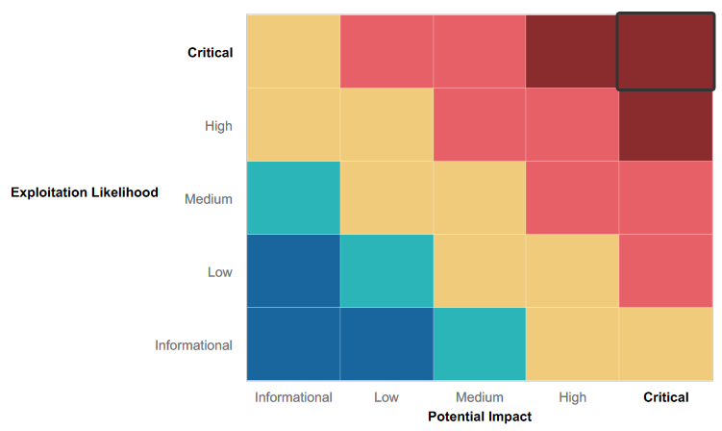

## 

### Summary of Strengths

While the assessment team was successful in finding several vulnerabilities, the team also recognized several strengths within MegaCorpOne’s environment. These positives highlight the effective countermeasures and defenses that successfully prevented, detected, or denied an attack technique or tactic from occurring.

* Firewall is present and installed on their network; even though it is poor.
* Most (not all) ports were well secured, it was difficult to connect to them.
* OpenSSH service on the server was not exploitable.

Overall, some input validations were utilized and filtration for some command injections was evident.

### Summary of Weaknesses

BSS successfully found several critical vulnerabilities that should be immediately addressed in order to prevent an adversary from compromising the network. These findings are not specific to a software version but are more general and systemic vulnerabilities.

* Weak password on public web application
* Open Port(s).
* Reflected Cross-Site Scripting
* Stored Cross-Site Scripting
* Local File Inclusion Vulnerability | ‘Memory-planner’ page
* Local File Inclusion Vulnerability | Name manipulation
* Sensitive Data Exposure | IPs
* Sensitive Data Exposure | Robots.txt
* Sensitive Data Exposure | Login page
* Directory Transversal vulnerability.
* CVE-2019-14287 Exploit on vulnerability (SSH)
* Command Injection | Networking page
* Brute Force Attack | Login page
* PHP Injection | Souvenirs page
* Session Management Vulnerability
* SQL Injection | Login Page
* RCE Exploit | .11 IP
* RCE Exploit | .10 IP
* RCE Exploit | .13 IP
* RCE Exploit | .12 IP

# 

## Executive Summary

Our assessment of MegaCorpOne revealed both positive security measures and critical vulnerabilities that need attention to strengthen the company’s overall defenses. While the presence of a firewall and some input validation measures have added layers of protection, several gaps leave the network exposed to potential threats.

One key issue is the use of weak passwords, which were easily cracked, likely due to an inadequate password policy. We also found vulnerabilities such as Local File Inclusion (LFI) and Cross-Site Scripting (XSS) that could be exploited by attackers. Additionally, sensitive data is unencrypted, network traffic is easy to intercept, and public exposure of domain server IP addresses increases the risk of targeted attacks. Certain open ports with vulnerable services further add to the threat landscape.

That said, the network does have some strengths. For example, OpenSSH proved resilient against attempts to exploit it, and many ports were well-secured, making unauthorized access challenging in those cases. Input validation measures also helped prevent some command injection attempts, showcasing that security best practices are being applied in parts of the system.

To address the risks identified, we recommend strengthening password policies, encrypting sensitive data, securing network traffic, and closing or hardening vulnerable open ports. Fixing the LFI and XSS vulnerabilities through better coding practices will also make a significant difference. Taking these steps will help MegaCorpOne reduce its vulnerabilities and build a more robust defense against potential attacks.

BantuShield Security, LLC, began the PenTest by collecting a list of employee names/emails. the following users are readily available online through a simple google dorking search: Joe Sheer (CEO [joe@megacorpone.com](mailto:joe@megacorpone.com)), Mike Carlow (VP of Legal [mcarlow@megacorpone.com](mailto:mcarlow@megacorpone.com)), Alan Grofield (IT/Security Director [agrofield@megacorpone.com](mailto:agrofield@megacorpone.com)), Tom Hudson (Web Designer [thudson@megacorpone.com](mailto:thudson@megacorpone.com)), Tanya Rivera (Senior Developer, [trivera@megacorpone.com](mailto:trivera@megacorpone.com)), and Matt Smith (Marketing Director [msmith@megacorpone.com](mailto:msmith@megacorpone.com)).

Find links used to find executive staff information: <https://www.megacorpone.com/about.html> and <https://www.megacorpone.com/contact.html> . We continued searching and found further internal/sensitive data that is publicly available/accessible, see screenshot(s) in the next page of some examples:

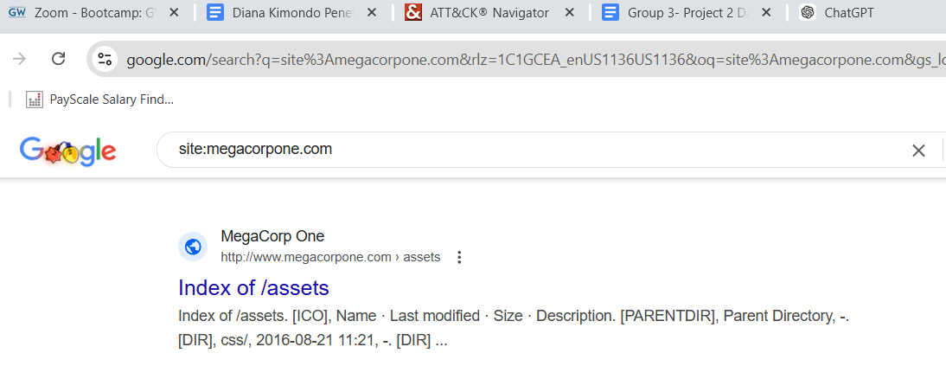

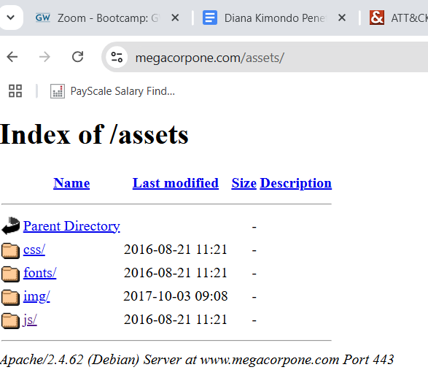

NS Lookup

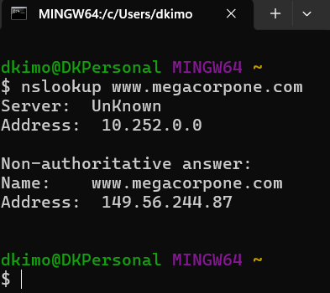

shodan.io

# 

Whois by Domain search

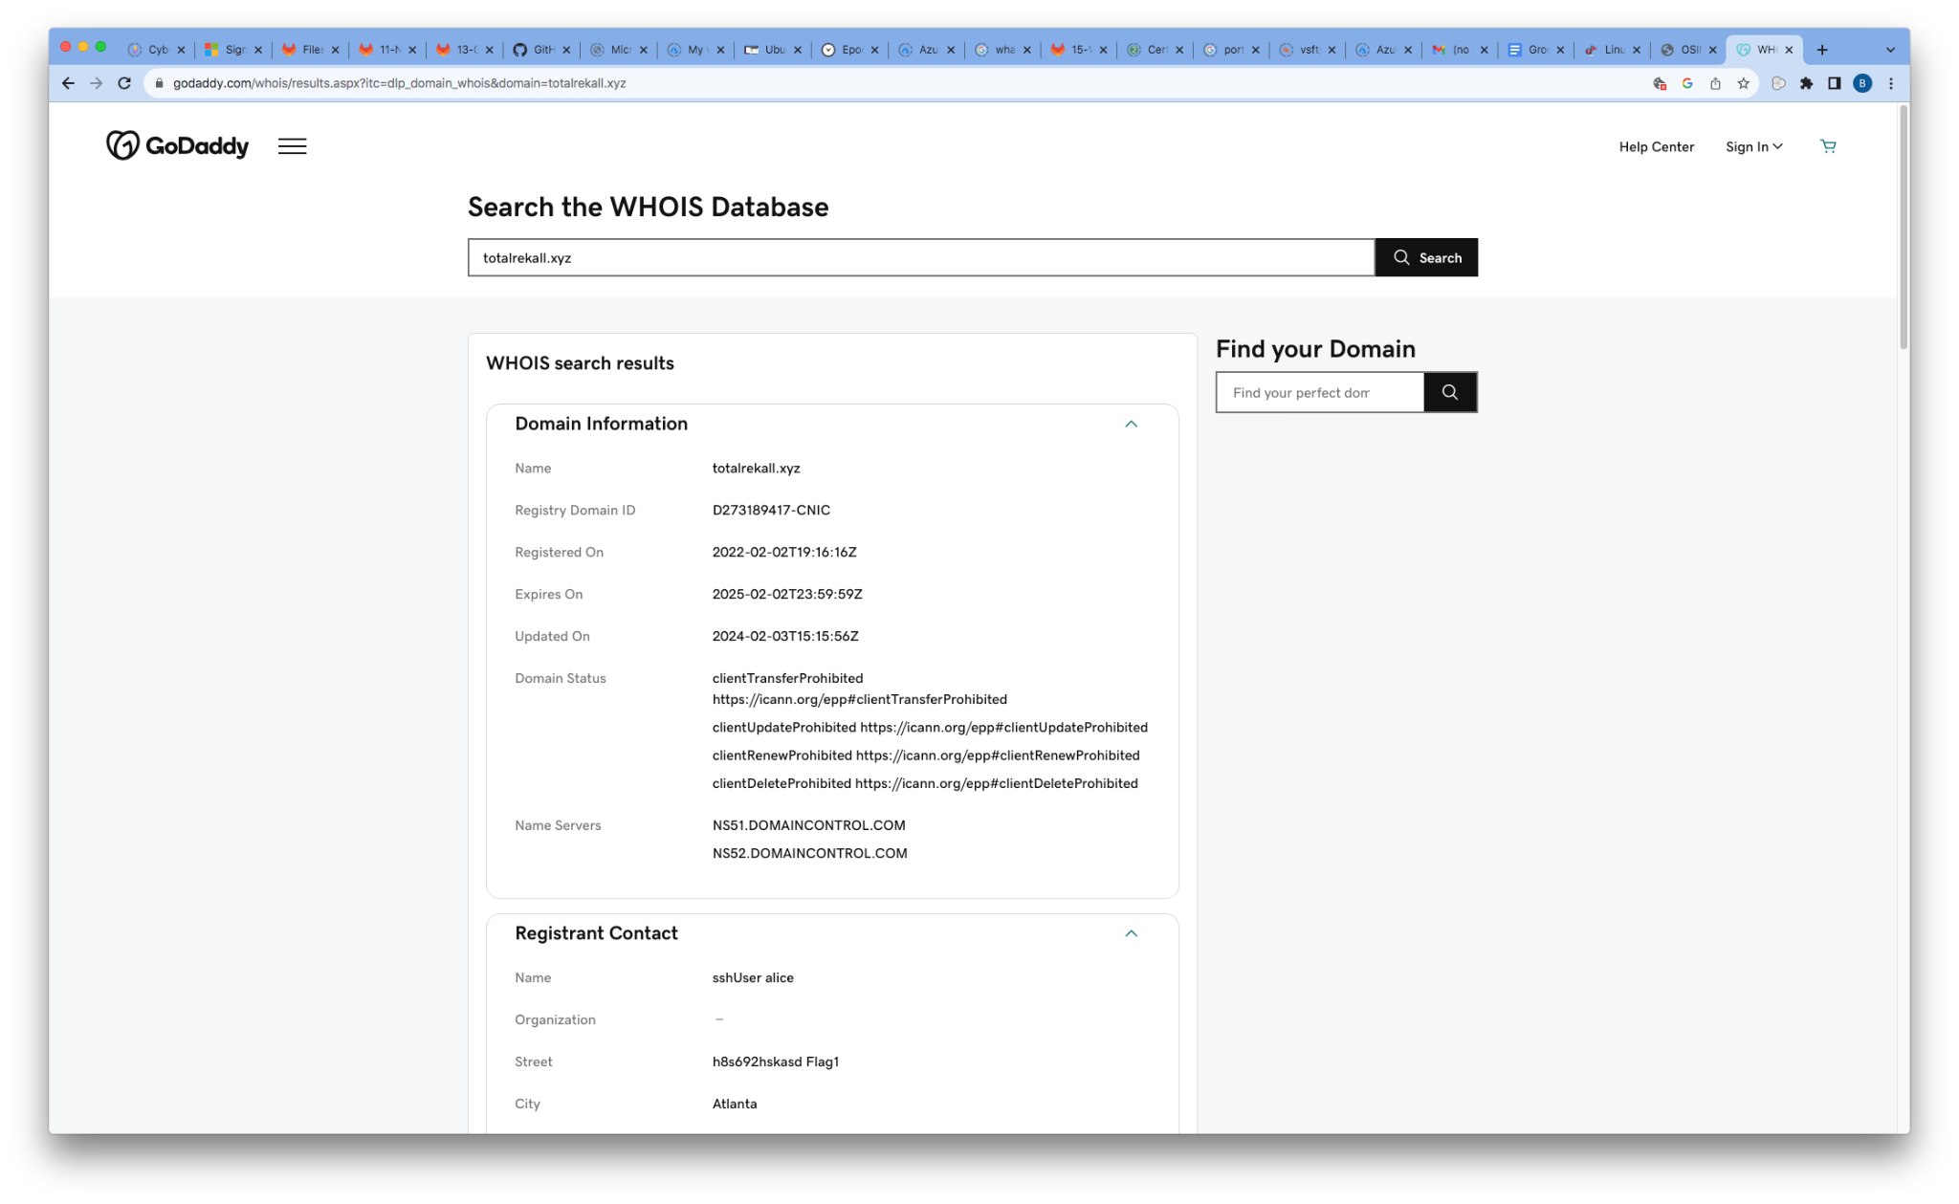

From the provided screenshots, we can identify critical details about the target system. The web page is hosted on a server running **Apache/2.4.38**, and the following ports are open for potential exploitation: **Port 22 (SSH)**, **Port 80 (HTTP)**, and **Port 443 (HTTPS)**. These findings provide valuable insight into the system's configuration and possible attack vectors. We were well armed to continue our testing.

## Summary Vulnerability Overview

| **Vulnerability** | **Severity** |
| --- | --- |
| Weak password on public web application | **Medium** |
| Open Port(s) | **High** |
| Reflected Cross-Site Scripting | **High** |
| Stored Cross-Site Scripting | **High** |
| Local File Inclusion Vulnerability | ‘Memory-planner’ page | **High** |
| Local File Inclusion Vulnerability | Name Manipulation | **High** |
| Sensitive Data Exposure | IPs | **Medium** |
| Sensitive Data Exposure | Robots.txt | **Medium** |
| Sensitive Data Exposure | Login Page | **Medium** |
| Directory Transversal Vulnerability | **Medium** |
| CVE-2019-14287 Exploit on Vulnerability (SSH) | **Critical** |
| Command Injection | Networking page | **High** |
| Brute Force Attack | Login page | **High** |
| PHP Injection | Souvenirs page | **High** |
| SQL Injection | Login page | **High** |
| RCE Exploit | .11 IP | **Critical** |
| RCE Exploit | .10 IP | **Critical** |
| RCE Exploit | .13 IP | **Critical** |
| RCE Exploit | .12 IP | **Critical** |

The following summary tables represent an overview of the assessment findings for this penetration test:

| **Scan Type** | **Total** |
| --- | --- |
| Hosts | 194.56.244.87  vpn.megacorpone.com  172.22.117.100 HOST  172.22.117.150 Linux  172.22.117.20 Windows 10  172.22.117.10 WINDC01 |
| Ports | Linux  21 FTP, 22 SSH, 80 HTTP  Windows 10  139 RPC/SMB, 135 RPC, 445 SMB, 3389 RDP  WinDC01  88 Kerberos, 445 SMB, 135 RPC |

| **Exploitation Risk** | **Total** |
| --- | --- |
| **Critical** | 5 |
| **High** | 10 |
| **Medium** | 5 |
| **Low** | - |

## Vulnerability Findings

### Weak Password on Public Web Application

**Risk Rating**: **Medium**

**Description**:

The site **vpn.megacorpone.com** is used to host the Cisco AnyConnect configuration file for MegaCorpOne. This site is secured with basic authentication but is susceptible to a dictionary attack. BSS was able to use a username gathered from OSINT in combination with a wordlist in order to guess the user’s password and access the configuration file.

**Affected Hosts**: vpn.megacorpone.com, 172.22.117.100, 172.22.117.150, 172.22.117.20, 172.22.117.10 (WINDC01)

**Remediation**:

* Set up two-factor authentication instead of basic authentication to prevent dictionary attacks from being successful.
* Require a strong password complexity that requires passwords to be over 12 characters long, upper+lower case, & include a special character.
* Reset the user **thudson**’s and **Rivera’s** passwords.

### Open Port(s)

**Risk Rating**: **High**

**Description**:

After identifying the server, I used nslookup and Shodan.io to gather information about potential vulnerabilities. By identifying open ports, I was able to determine which services were accessible on the server, providing insights into potential security risks and areas for further investigation. Refer to the executive summary page for screenshots that detail these findings.

**Affected Hosts**: vpn.megacorpone.com, 172.22.117.100, 172.22.117.150, 172.22.117.20, 172.22.117.10 (WINDC01)

Additional finding

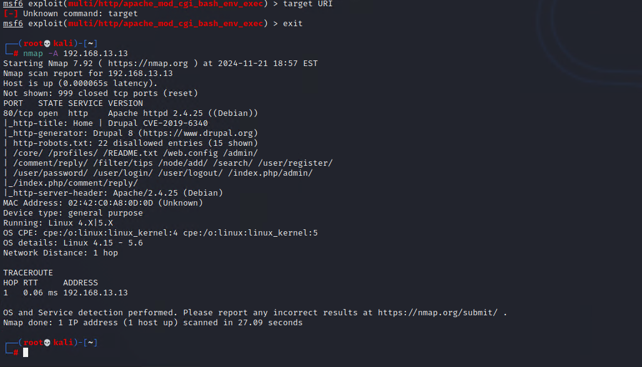

**Remediation**:

* **Close Unnecessary Ports**: Analyze and identify which ports are not essential to the server’s operation and close them to reduce the attack surface. Only keep open those ports required for necessary services and applications.
* **Implement Network Segmentation**: Divide the network into segments based on the sensitivity of the data and functionality of the services. Use firewalls and access controls to limit communication between segments, reducing the risk of unauthorized access.
* **Configure a Proper Firewall**: Use a firewall to manage incoming and outgoing traffic. Configure it to allow only trusted traffic and block traffic from untrusted sources. Monitor and log traffic to detect any anomalies or attempts to exploit open ports.

### Reflected Cross-Site Scripting

**Risk Rating**: **High**

**Description**:

We discovered reflected Cross-Site Scripting (XSS) vulnerabilities on both the "welcome" page and the "memory-planner" page. On the welcome page, the "put your name here" input field failed to sanitize user input, allowing me to inject a script that triggered an alert pop-up. This demonstrated that malicious scripts could be executed, potentially enabling attackers to inject harmful code into a trusted website. Similarly, on the memory-planner page, I bypassed input validation with a payload script, leading to successful execution. These vulnerabilities expose users to security risks, such as phishing attacks, session hijacking, or the unauthorized execution of malicious code.

**Affected Hosts**: vpn.megacorpone.com, WINDC01, Windows 10

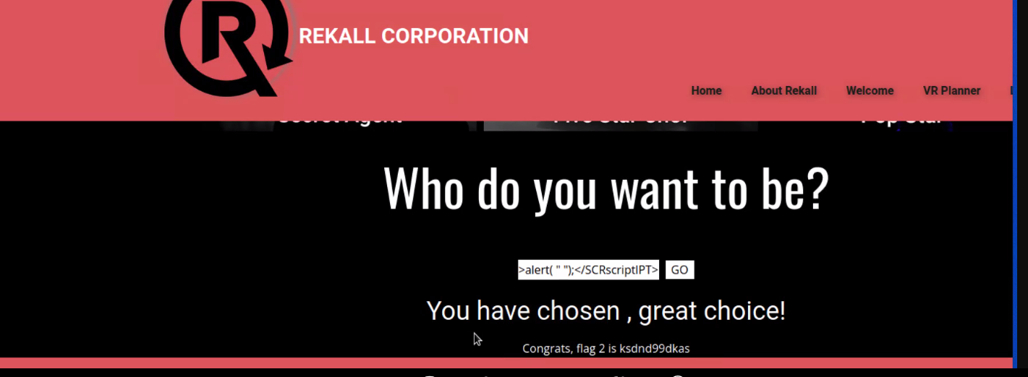

**Remediation**:

* **Implement Proper Input Validation**: Sanitize and validate all user inputs to ensure scripts, special characters, and HTML tags cannot be executed. Use whitelisting approaches where only expected inputs are allowed.
* **Use Output Encoding**: Encode user-generated data before rendering it in the browser to prevent it from being interpreted as executable code. Tools like HTML entity encoding can help mitigate XSS.
* **Implement HTTPOnly and Secure Cookies**: Ensure cookies are set with the HTTPOnly flag to prevent access via JavaScript, and use the Secure flag to protect cookies during transmission over HTTPS. This helps mitigate the risk of session hijacking in case of a successful XSS attack.

### Stored Cross-Site Scripting

**Risk Rating**: **High**

**Description**:

We exploited the comments page by injecting a payload into the input field. The comments page contained a stored XSS (Cross-Site Scripting) vulnerability, which allowed me to execute malicious scripts that were stored and later executed when users viewed the comments. This could potentially lead to unauthorized access, data theft, or the compromise of users’ sessions.

**Affected Hosts**: vpn.megacorpone.com, WINDC01, HOST

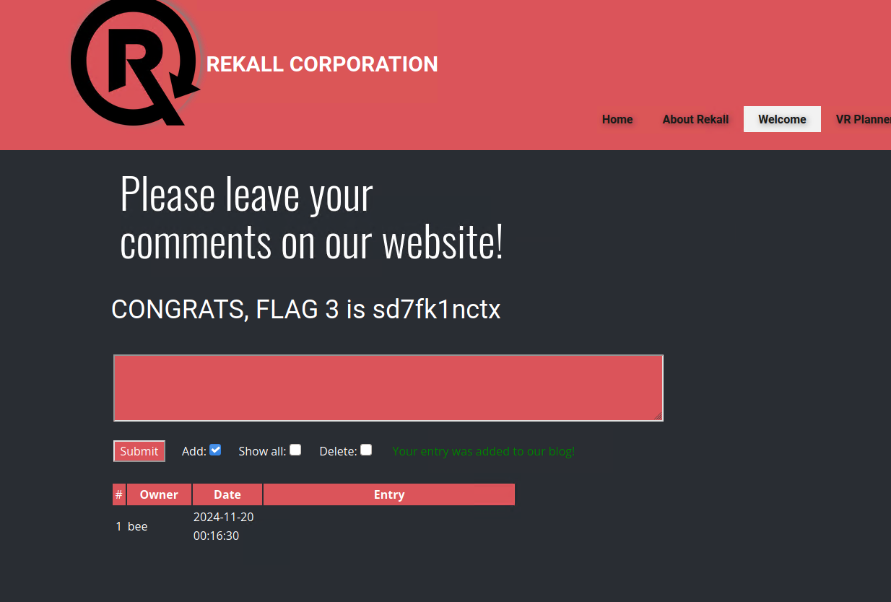

**Remediation**:

* **Sanitize Input**: Ensure all input fields on the comments page are properly sanitized to prevent the injection of scripts or HTML content. This includes removing or encoding potentially harmful characters.
* **Apply Web Application Firewalls (WAF)**: Deploy a Web Application Firewall (WAF) to monitor, filter, and block malicious traffic, including XSS attacks, before they reach the server. A WAF can also help prevent attempts to inject malicious content into input fields.
* **Educate Users and Administrators**: Educate users and administrators about the risks of XSS attacks and the importance of input validation and secure coding practices. Encourage them to follow security best practices, such as reporting suspicious content and using software that supports secure coding standards.

### Local File Inclusion | Memory-planner page

**Risk Rating**: **High**

**Description**:

I exploited an LFI (Local File Inclusion) vulnerability on the **memory-planner** page by uploading a PHP file. This trick allowed me to bypass the standard file inclusion checks and include my malicious file on the server. By exploiting this vulnerability, I was able to gain unauthorized access to the server's file system, potentially allowing me to execute arbitrary code or gain additional control over the system.

**Affected Hosts**: vpn.megacorpone.com, WINDC01, Linux host



**Remediation**:

* **Validate and Sanitize File Inputs**: Ensure that all file inputs are properly validated and sanitized to prevent unexpected file extensions or file types from being uploaded. Implement checks to verify that files being uploaded are only those that are explicitly allowed by the application.
* **Restrict File Uploads**: Limit file uploads to specific directories and restrict the types of files that can be uploaded. Use mechanisms such as file type whitelisting and blacklisting to prevent the upload of potentially harmful files, such as executable scripts.
* **Secure the Application Code**: Review and secure the application code to eliminate any LFI vulnerabilities. This includes auditing how file paths are handled, using parameterized queries, and ensuring that file inclusion is done securely. Regular security assessments and code reviews can help identify and fix these vulnerabilities.

### Local File Inclusion | Name Manipulation

**Risk Rating**: **High**

**Description**:

The 'Memory-Planner' page was found to be vulnerable to a Local File Inclusion (LFI) exploit. By leveraging a name manipulation vulnerability, I was able to rename a .jpg file to .php and successfully upload it to the server. This allowed execution of the malicious .php file, potentially granting unauthorized access to sensitive information or enabling further exploitation of the system. This highlights a lack of proper input validation and insufficient restrictions on file upload functionality

**Affected Hosts**: vpn.megacorpone.com, WINDC01, Windows 10

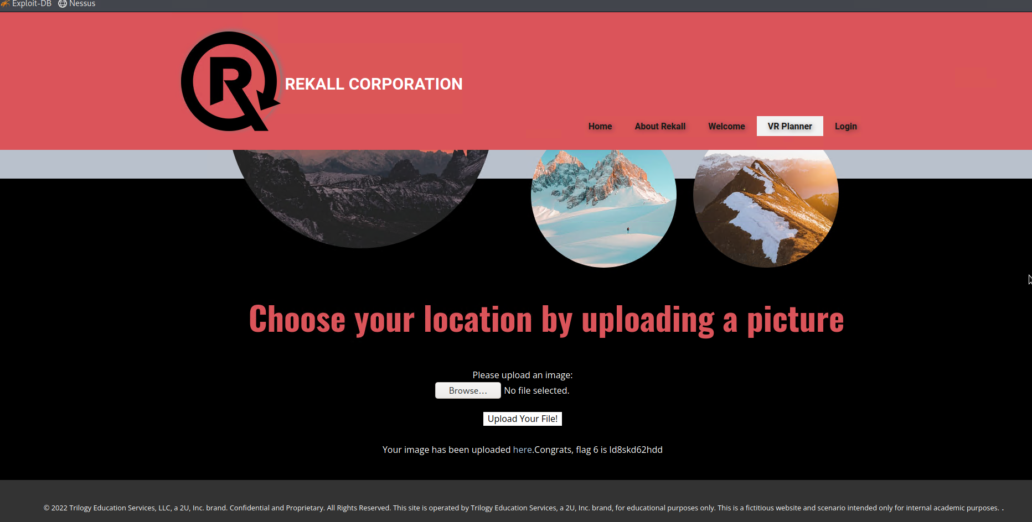

**Remediation**:

* **Validate and Sanitize File Inputs**: Ensure that all file inputs are properly validated and sanitized to prevent unexpected file extensions or file types from being uploaded. Implement checks to verify that files being uploaded are only those that are explicitly allowed by the application.
* **Restrict File Uploads**: Limit file uploads to specific directories and restrict the types of files that can be uploaded. Use mechanisms such as file type whitelisting and blacklisting to prevent the upload of potentially harmful files, such as executable scripts.
* **Secure the Application Code**: Review and secure the application code to eliminate any LFI vulnerabilities. This includes auditing how file paths are handled, using parameterized queries, and ensuring that file inclusion is done securely. Regular security assessments and code reviews can help identify and fix these vulnerabilities.

### Sensitive Data Exposure | IPs

**Risk Rating**: **Medium**

**Description**:

The sensitive data we were able to access on **vpn.megacorpone.com** includes information about the server type (Apache/2.4.38), open ports (22, 80, 443), internal data, IP addresses, and executive staff usernames (see executive summary above). These details highlight potential vulnerabilities that could be exploited to gain unauthorized access or compromise the system's security. For more information, refer to the executive summary page with screenshots of this data.

**Affected Hosts**: vpn.megacorpone.com (all)

nmap on 192.168.13.0/24 to find all the other ip

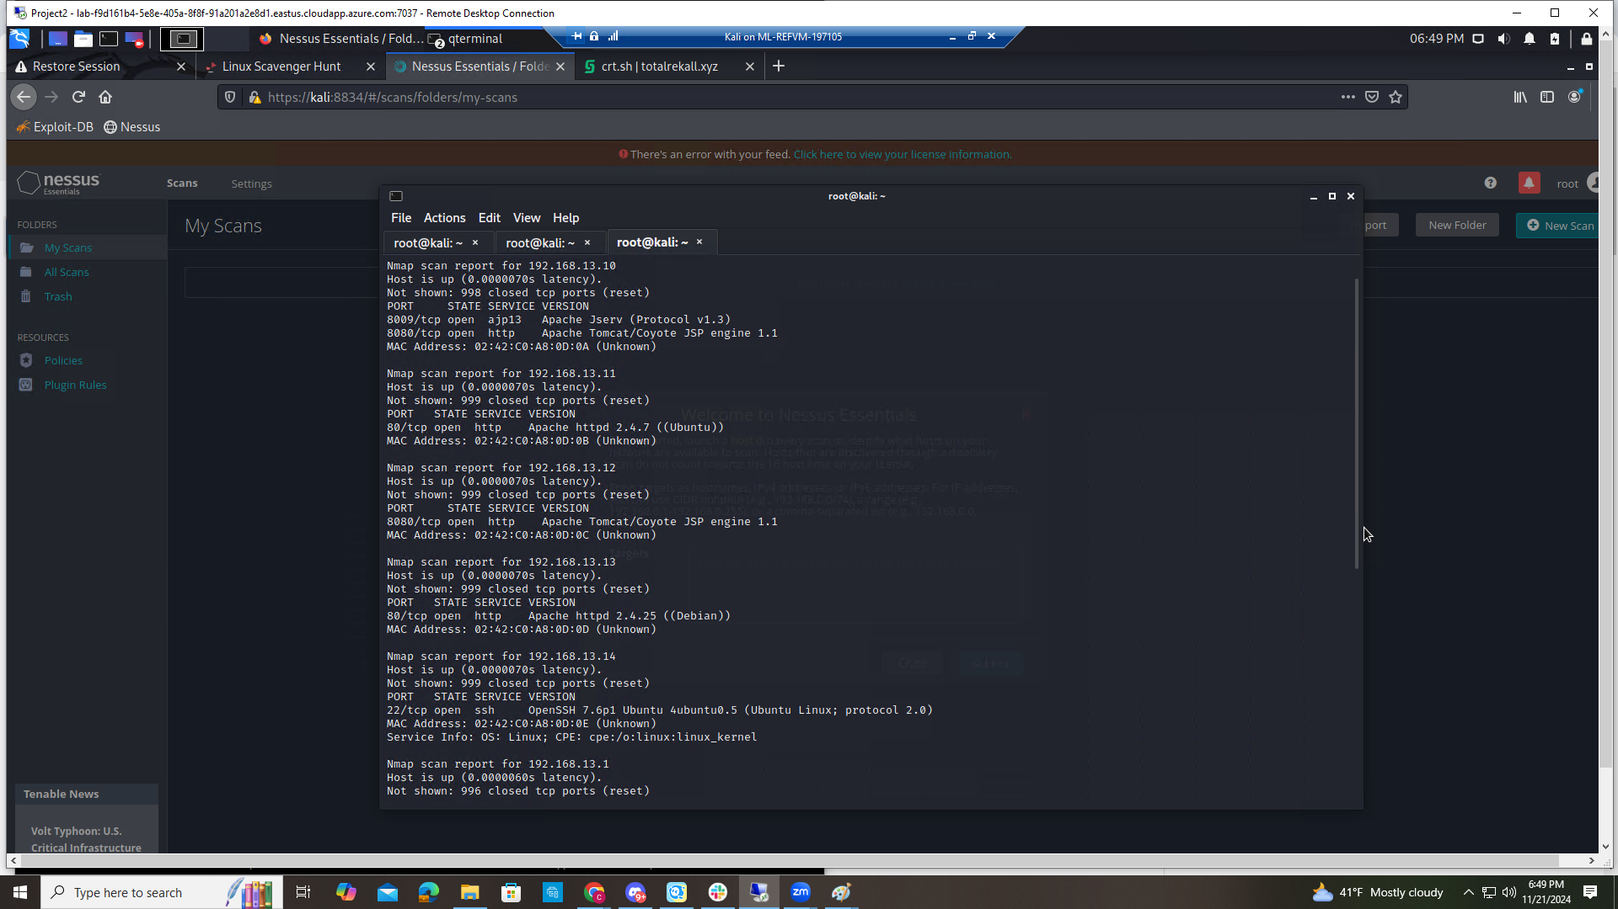

**Remediation**:

* **Implement Strong Encryption**: Ensure that sensitive data such as server information, open ports, IP addresses, and executive usernames are encrypted both in transit and at rest to prevent unauthorized access.
* **Secure Access Controls**: Restrict access to sensitive information to only those who absolutely need it. Implement role-based access control (RBAC) to limit permissions and reduce the risk of unauthorized access.
* **Update and Patch Systems**: Keep all software, including the Apache server and any associated libraries, up-to-date with the latest security patches to protect against known vulnerabilities that could be exploited to access sensitive data.

### Sensitive Data Exposure | Robots.txt

**Risk Rating**: **Medium**

**Description**:

The application was vulnerable to sensitive data exposure through improper access controls. By inspecting the robots.txt file, I was able to access an internal document containing sensitive data. This highlights a misconfiguration that exposed confidential information intended to remain hidden from public view.

**Affected Hosts**: vpn.megacorpone.com, WINDC01, Linux host

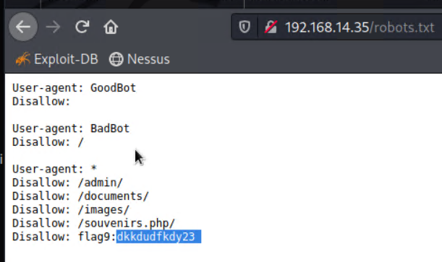

**Remediation**:

* **Restrict Access to Sensitive Files:** Use appropriate server configurations to ensure files like robots.txt do not expose sensitive or internal information.
* **Implement Least Privilege:** Limit access to sensitive documents and directories to only authorized users or systems.
* **Conduct Regular Security Audits:** Periodically review and update the robots.txt file and other configurations to ensure no sensitive data is unintentionally exposed.

### Sensitive Data Exposure | Login page

**Risk Rating**: **Medium**

**Description**:

A sensitive data exposure vulnerability was identified on the 'login' page. Credentials were found embedded within the HTML source code, making them accessible to anyone inspecting the page. This indicates a failure to securely handle sensitive information, increasing the risk of unauthorized access and exploitation.

**Affected Hosts**: vpn.megacorpone.com, WINDC01, Windows 10

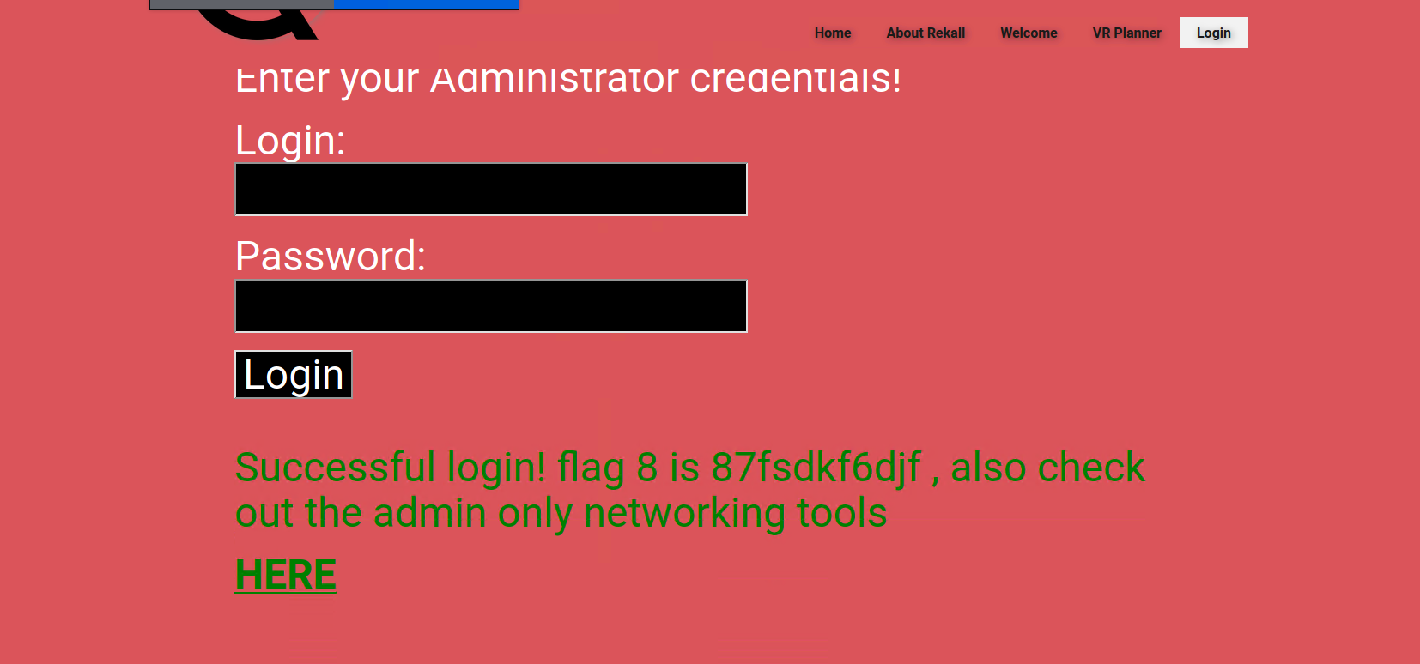

**Remediation**:

* **Remove Sensitive Data from Source Code:** Ensure credentials and other sensitive information are not hard coded or exposed in the HTML source. Store them securely on the server side.
* **Implement Secure Authentication Practices:** Use environment variables or encrypted storage for credentials and ensure they are only accessible to the backend systems.
* **Conduct Code Reviews and Security Testing:** Regularly review application code and perform security testing to identify and address exposure of sensitive data.

### Directory Traversal Vulnerability

**Risk Rating**: **Medium**

**Description**:

We identified a Directory Traversal vulnerability on the "disclaimer.php" page, which allowed unauthorized access to files and directories on the server. By exploiting a common injection flaw, I was able to navigate through the server's directory structure and potentially access sensitive files. This vulnerability occurs due to improper input validation, enabling attackers to manipulate file paths and retrieve unauthorized data or execute malicious actions.

**Affected Hosts**: vpn.megacorpone.com, WINDC01, HOST

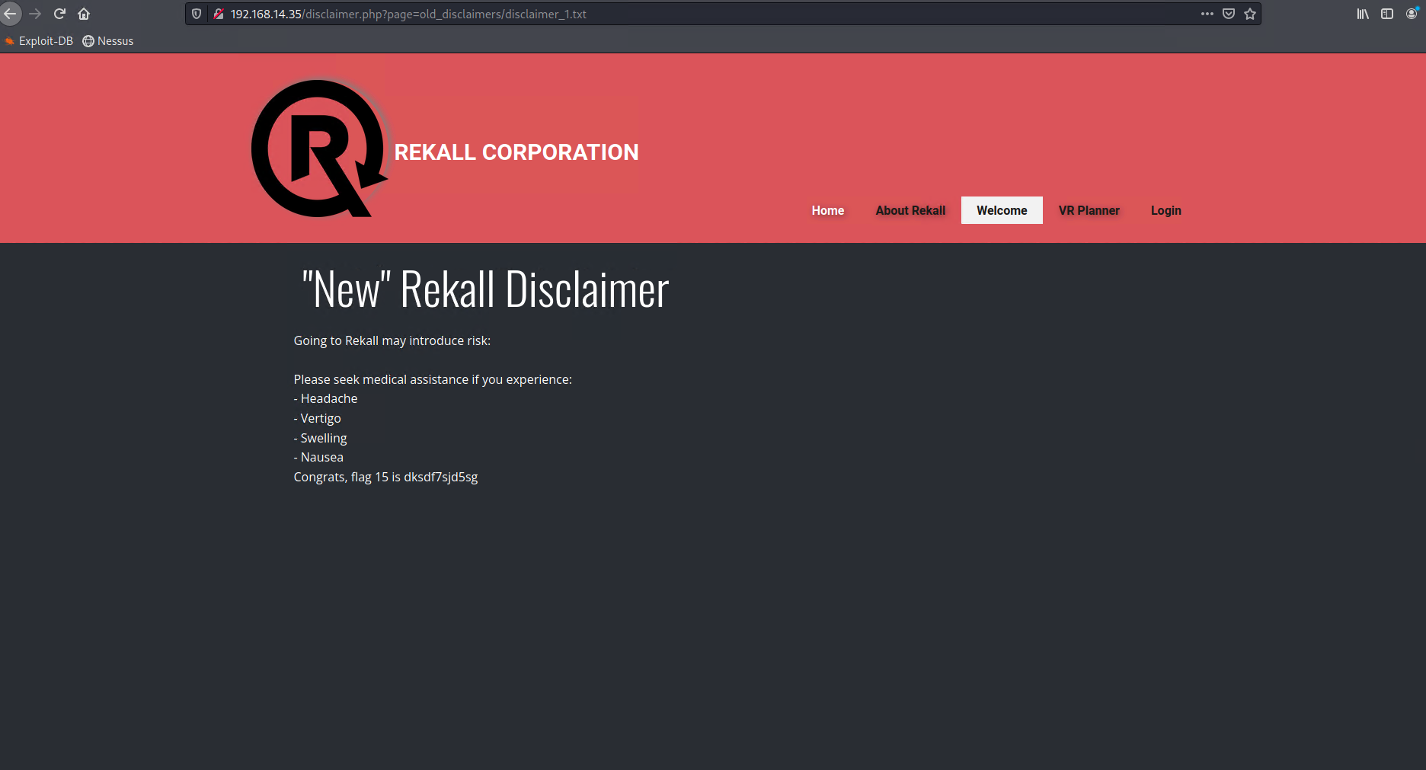

**Remediation**:

* **Validate and Sanitize User Inputs**: Ensure all input fields that interact with file systems are validated and sanitized to prevent directory traversal characters such as ../ or absolute file paths from being processed.
* **Use Secure File Handling Functions**: Restrict file access to specific directories using secure coding practices, such as using realpath() to resolve and verify paths before accessing files. Avoid directly concatenating user inputs to file paths.
* **Apply Least Privilege Permissions**: Limit file and directory permissions on the server so that even if traversal occurs, access to sensitive files is denied. Configure the application to operate with minimal privileges required for functionality.

### CVE-2019-14287 Exploit on Vulnerability (SSH)

**Risk Rating**: **Critical**

**Description**:

We exploited **CVE-2019-14287** to escalate privileges through SSH on **vpn.megacorpone.com**. This vulnerability allowed me to gain unauthorized higher-level access to the system, bypassing security controls and gaining full control over the server.

**Affected Hosts:** 172.22.117.100 (HOST), 172.22.117.150 (LINUX), 172.22.117.20 (Windows 10), or 172.22.117.10 (WINDC01)

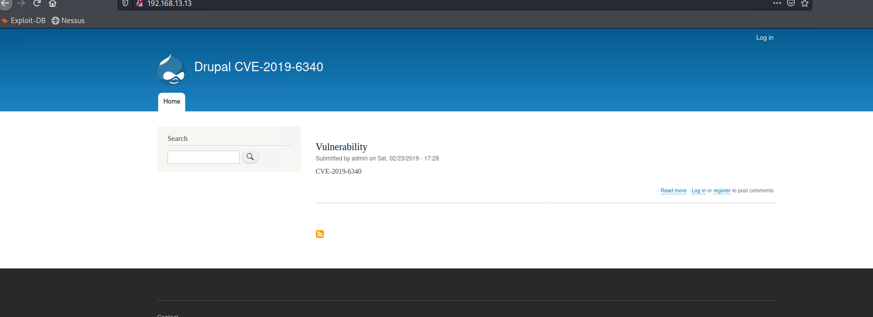

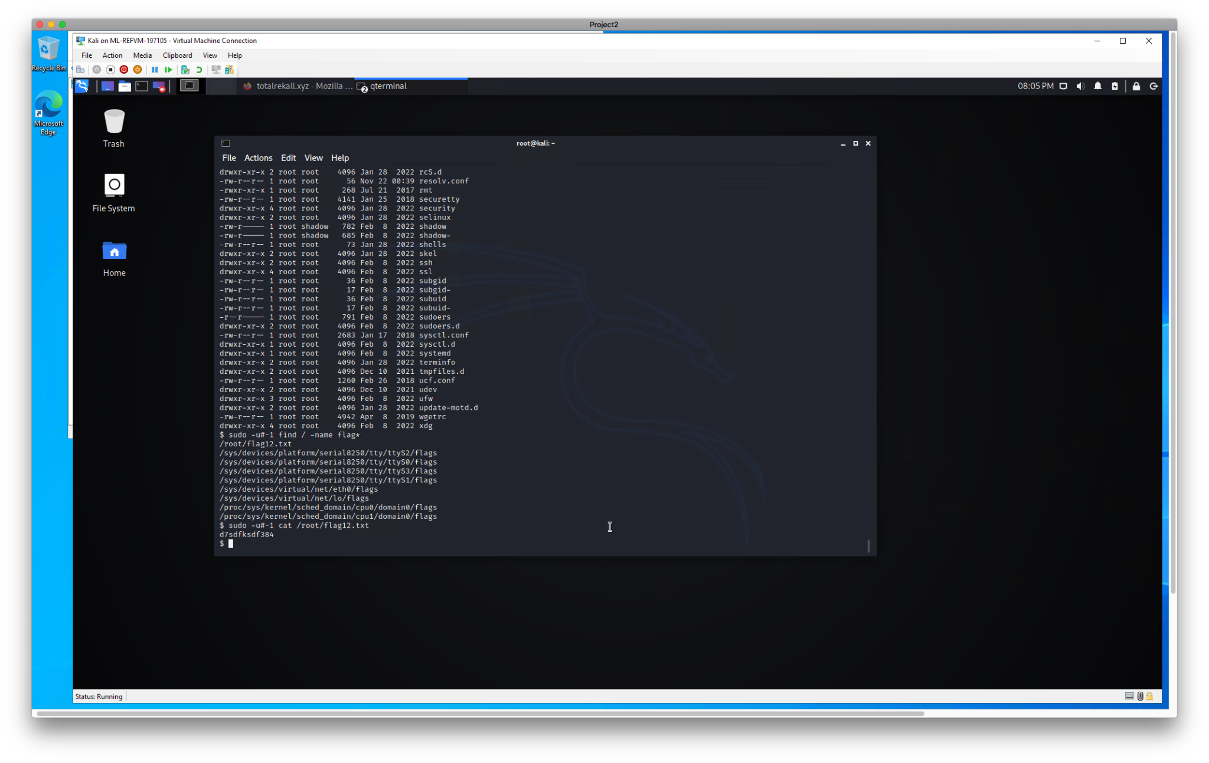

**Remediation**:

* **Patch the Vulnerability**: Apply the latest security patches to update the SSH implementation on **vpn.megacorpone.com** to fix the flaw identified in **CVE-2019-14287**. Keeping the system up-to-date with security updates is crucial to protect against such exploits.
* **Restrict SSH Access**: Implement stricter access controls for SSH. Use techniques such as SSH keys with passphrases, disable root login, and limit access to specific IP addresses or network ranges to reduce the attack surface. While doing this, regularly monitor SSH login attempts and audit the systems access logs.
* **Enable Two-Factor Authentication (2FA)**: Implement two-factor authentication (2FA) for SSH access. This adds an extra layer of security by requiring a second form of verification, such as a time-based one-time password (TOTP) or an SMS verification code, in addition to the username and password.

### Command Injection | Networking Page

**Risk Rating**: **High**

**Description**:

A vulnerability was found on the 'Networking' page that allowed me to run system commands by entering a special payload into a user input field. The system accepted the input without proper checks, which let me control parts of the server. This shows the page didn’t have enough security to block harmful inputs.

**Affected Hosts**: vpn.megacorpone.com, WINDC01, HOST

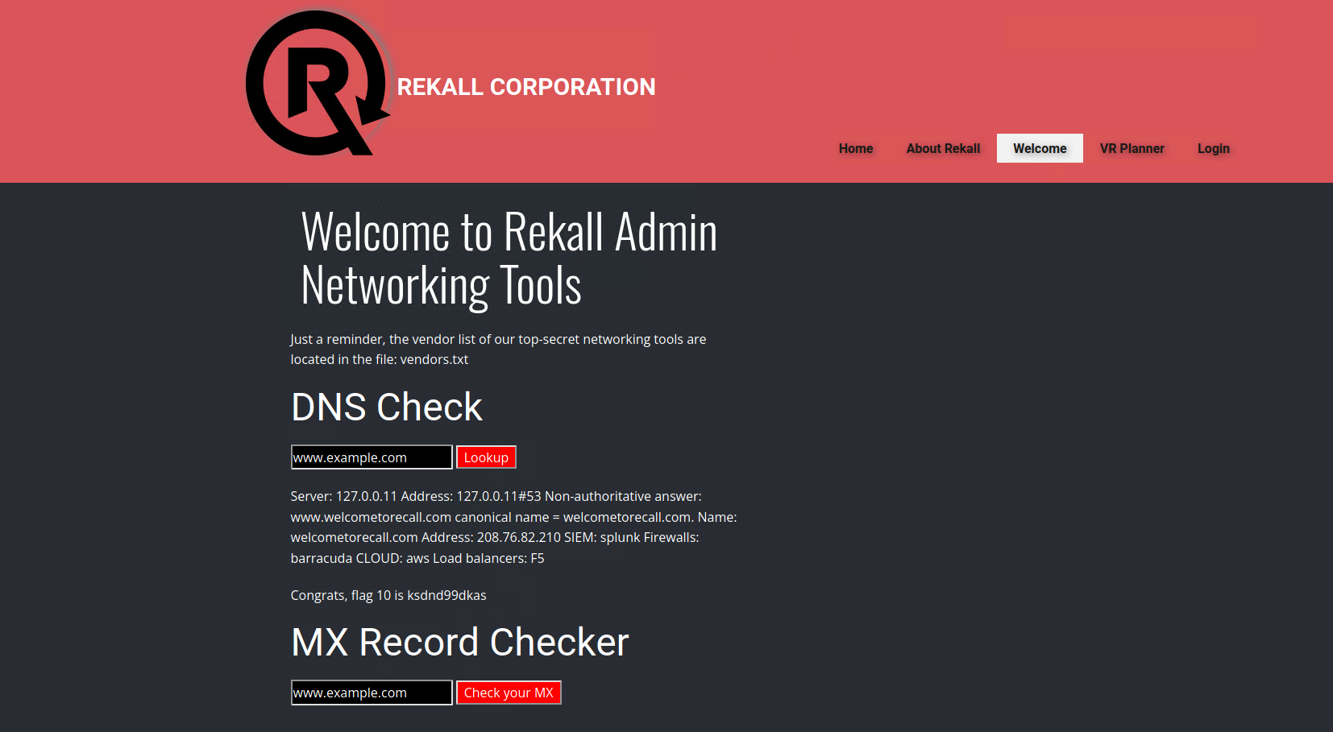

**Remediation**:

* **Validate and Sanitize User Input:** Ensure all user inputs are properly checked and sanitized to prevent malicious commands from being executed.
* **Use Parameterized Queries:** Avoid directly using user input in system commands; use secure methods like parameterized queries or prepared statements.
* **Implement Least Privilege:** Restrict the server's permissions to limit the impact of a successful attack, ensuring it only has access to what is strictly necessary.

### Brute Force Attack | Login Page

**Risk Rating**: **High**

**Description**:

A brute force attack was performed on the 'Login' page using Burp Suite's Intruder tool. By testing simple password payloads, I was able to successfully guess a staff member's password. This indicates weak password policies and a lack of protections against automated login attempts.

**Affected Hosts**: vpn.megacorpone.com, WINDC01, Windows 10

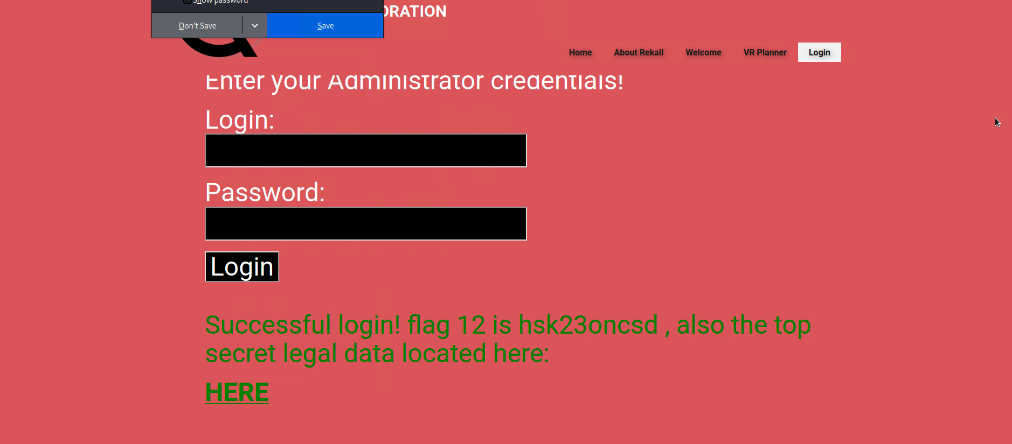

**Remediation**:

* **Implement Strong Password Policies:** Enforce strong password requirements, such as minimum length, complexity, and expiration dates, to reduce the likelihood of successful brute force attacks.
* **Enable Account Lockout Mechanisms:** Implement account lockout mechanisms to prevent multiple failed login attempts, limiting the impact of brute force attempts.
* **Use Two-Factor Authentication (2FA):** Enable 2FA to add an extra layer of security, requiring users to provide additional verification, reducing the risk of unauthorized access through brute force attacks.

### PHP Injection | Souvenirs page

**Risk Rating**: **High**

**Description**:

A PHP injection vulnerability was discovered on the 'Souvenirs' page. By injecting a payload into the URL (;system('cat /etc/passwd')), I was able to execute arbitrary PHP commands on the server. This flaw allowed me to view sensitive system files, indicating a lack of proper input validation and security measures to prevent such injections.

**Affected Hosts**: vpn.megacorpone.com, WINDC01, Linux host

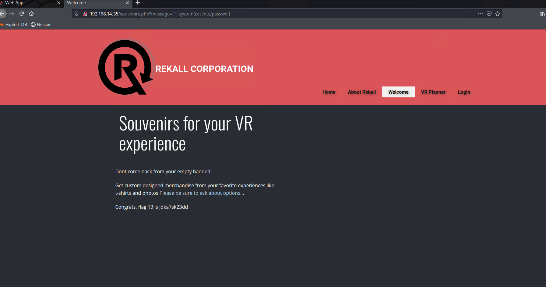

**Remediation**:

* **Sanitize Input:** Implement input validation and sanitization to ensure that user inputs do not execute harmful PHP commands or system calls. Use parameterized queries or prepared statements to prevent command injection vulnerabilities.
* **Secure Error Handling:** Improve error handling by disabling detailed error messages that could expose system information to attackers. Instead, log errors securely on the server side.
* **Use Web Application Firewalls (WAFs):** Deploy WAFs to monitor and block suspicious requests that could exploit PHP injection vulnerabilities. Regularly update and configure WAF rules to effectively defend against such attacks.

### Session Management Vulnerability

**Risk Rating**: **High**

**Description**:

A session management vulnerability was found on the 'admin_legal_data.php' page. By using the Burp Intruder tool to brute-force session IDs, I was able to gain unauthorized access to the administrative section. This indicates weak session handling, such as predictable or insufficiently complex session IDs, which could be exploited to bypass authentication and access sensitive data.

**Affected Hosts**: vpn.megacorpone.com, HOST, WINDC01, Linux host, Windows 10

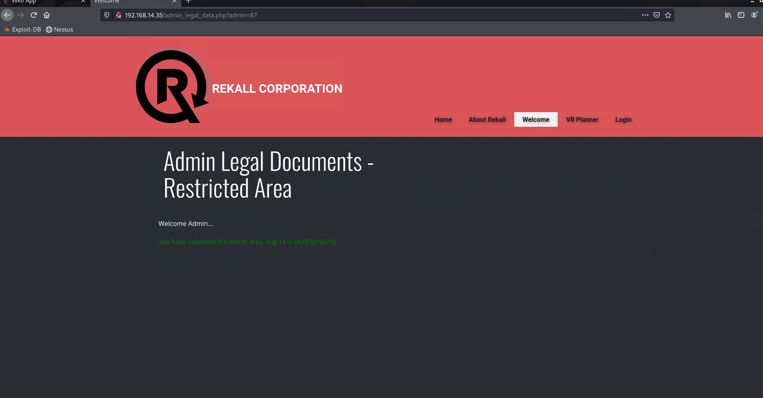

**Remediation**:

* **Implement Strong Session Management:** Use complex, unpredictable session IDs and regenerate them regularly. Avoid using session IDs that can be easily guessed or brute-forced.
* **Enable Session Expiration:** Set appropriate session expiration times to automatically log users out after a period of inactivity. This reduces the window of opportunity for attackers to exploit stale sessions.
* **Monitor Session Activity:** Implement monitoring and logging for session activities to detect and respond to suspicious behavior, such as multiple failed login attempts or unexpected session access patterns.

### SQL Injection | Login page

**Risk Rating**: **High**

**Description**:

A SQL injection vulnerability was discovered on the login page. Using a username obtained from a directory traversal attack, I was able to craft malicious SQL queries that could manipulate the database. This allowed me to bypass authentication and gain unauthorized access to sensitive information. The vulnerability highlights a lack of proper input validation and security measures to protect against SQL injection attacks.

**Affected Hosts**: vpn.megacorpone.com, WINDC01, HOST

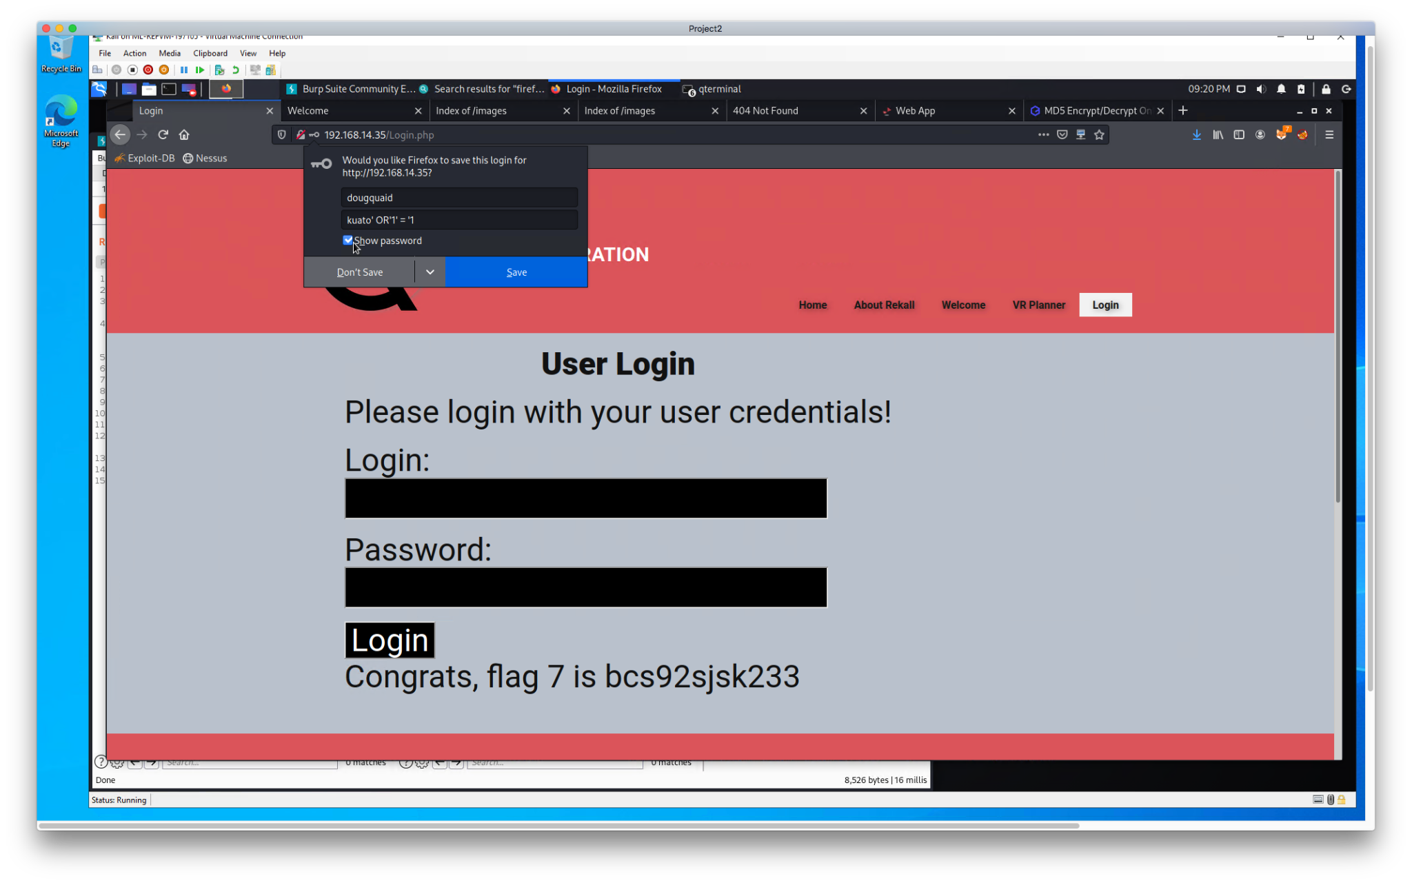

**Remediation**:

* Implement Input Validation and Sanitization: Use strong input validation techniques to ensure user inputs do not contain SQL commands. Use prepared statements or parameterized queries to prevent SQL injection.
* Enable Query Escaping and Error Handling: Properly escape database queries and handle errors securely to prevent attackers from gaining additional information that could be used to exploit the vulnerability.
* Regularly Update and Patch Systems: Keep all software, including database management systems and web applications, up-to-date with the latest security patches to protect against known SQL injection vulnerabilities.

### 

### RCE Exploit | .11 IP

**Risk Rating**: **Critical**

**Description**:

I discovered a vulnerability on the Apache server at 192.168.13.11 using the exploit/multi/http/apache_mod_cgi_bach_env_exec module. This module allowed me to execute arbitrary commands on the server via the Bash environment. This exploit takes advantage of improper handling of environment variables by the Apache mod_cgi, which can lead to remote code execution if not properly secured.

**Affected Hosts**: vpn.megacorpone.com, WINDC01, Linux host

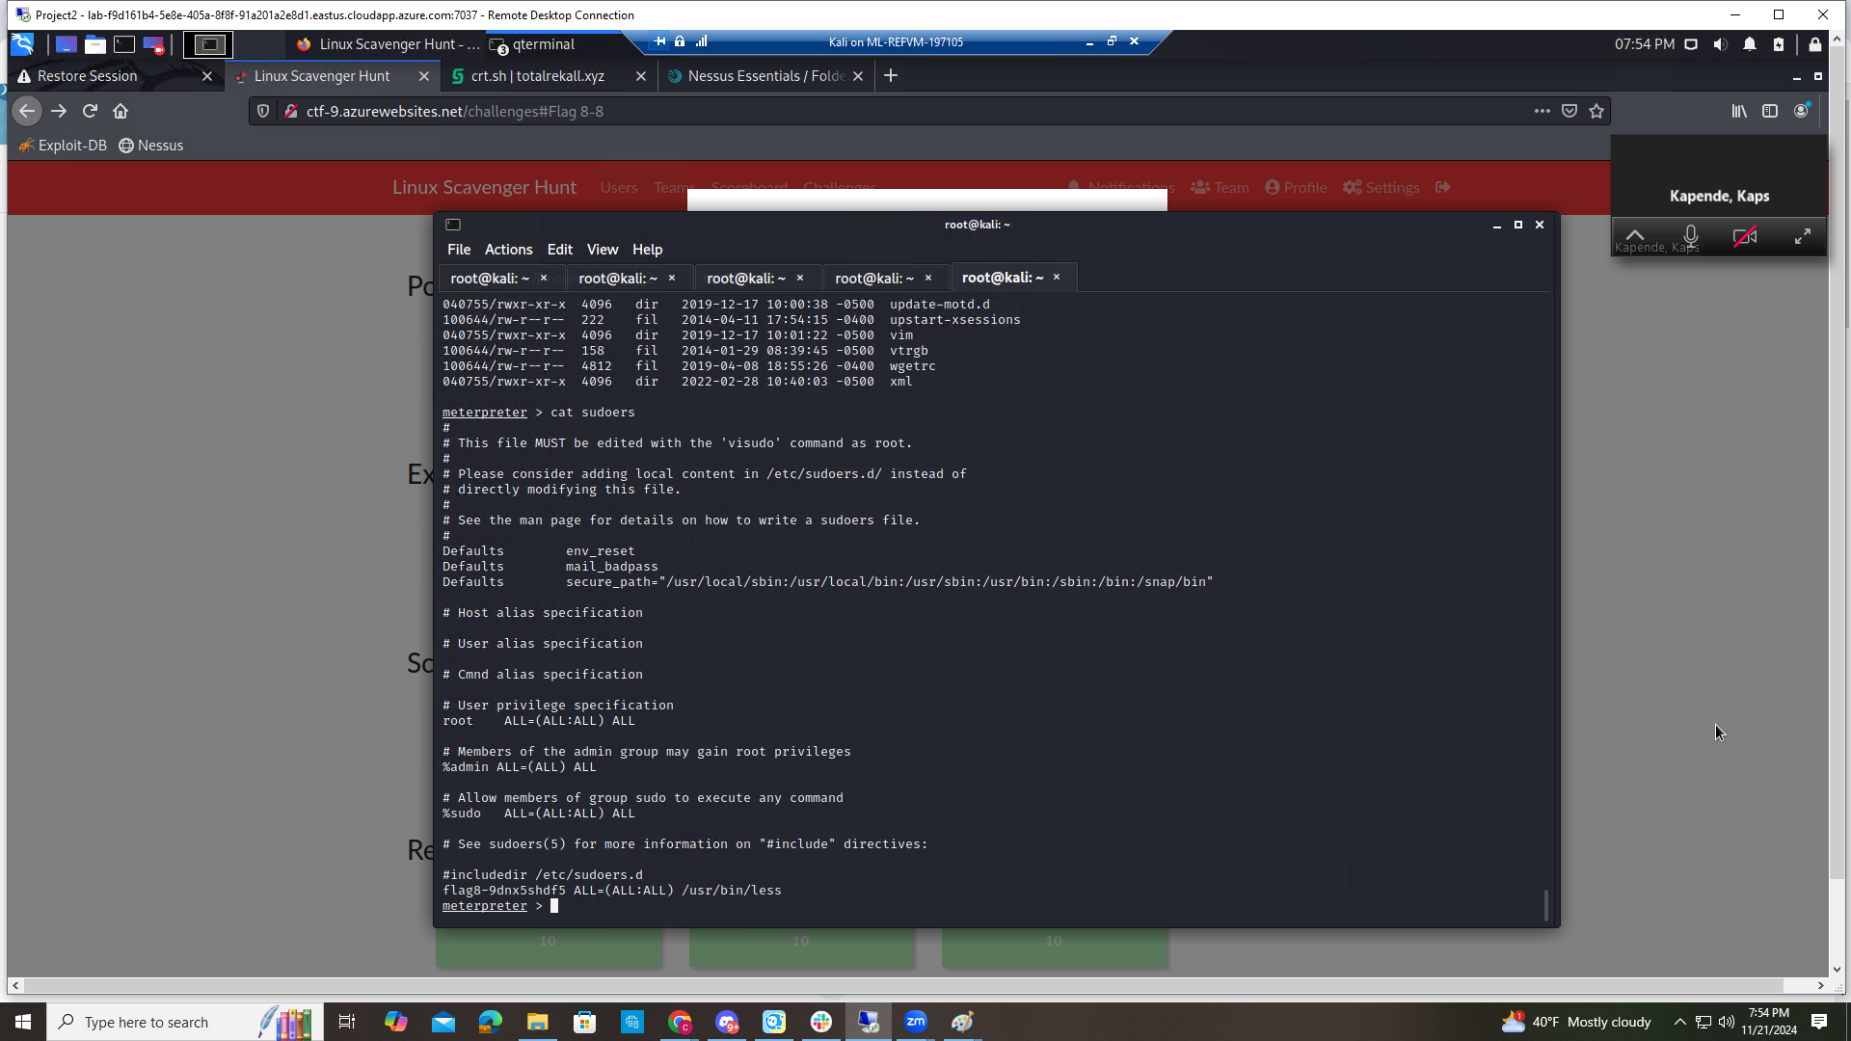

**Remediation**:

* **Restrict CGI Access**: Limit CGI script execution to trusted users and directories to reduce the risk of exploitation.
* **Disable Unnecessary Modules**: If CGI is not needed, disable the mod_cgi module on Apache to eliminate the vulnerability.
* **Sanitize Environment Variables**: Ensure that environment variables used by CGI scripts are properly sanitized to prevent the execution of unauthorized commands.

### RCE Exploit | .10 IP

**Risk Rating**: **Critical**

**Description**:

I used an RCE (Remote Code Execution) exploit on the Tomcat server at 192.168.13.10. By using the multi/http/tomcat_jsp_upload_bypass module, I was able to upload a malicious JSP file that allowed me to run commands on the server. This exploit took advantage of vulnerabilities in the Tomcat’s file upload feature, letting me execute arbitrary code remotely.

**Affected Hosts**: vpn.megacorpone.com, WINDC01, HOST

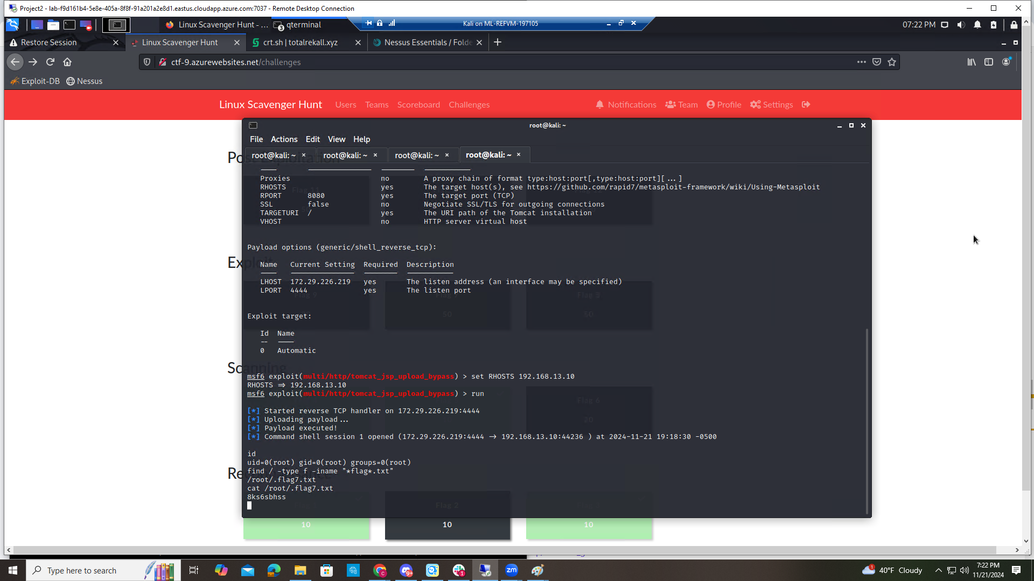

**Remediation**:

* **Limit File Upload Permissions**: Restrict file upload permissions to only trusted directories and ensure files uploaded through the web interface are properly validated and sanitized.
* **Update Tomcat to the Latest Version**: Keep the Tomcat server up-to-date with the latest security patches to protect against known vulnerabilities in file upload handling.
* **Configure Security Controls**: Set up proper security controls and access controls to prevent unauthorized file uploads and limit the execution of files on the server.

### RCE Exploit | .13 IP

**Risk Rating**: **Critical**

**Description**:

I conducted an RCE (Remote Code Execution) exploit on a server at 192.168.13.13 using the unix/webapp/drupal_restws_unserialize module. By exploiting a vulnerability in the Drupal REST Web Services (restws) module, I was able to inject malicious data that resulted in remote code execution. This exploit took advantage of improper input handling, allowing me to run arbitrary commands on the server.

**Affected Hosts**: vpn.megacorpone.com, WINDC01, Linux host

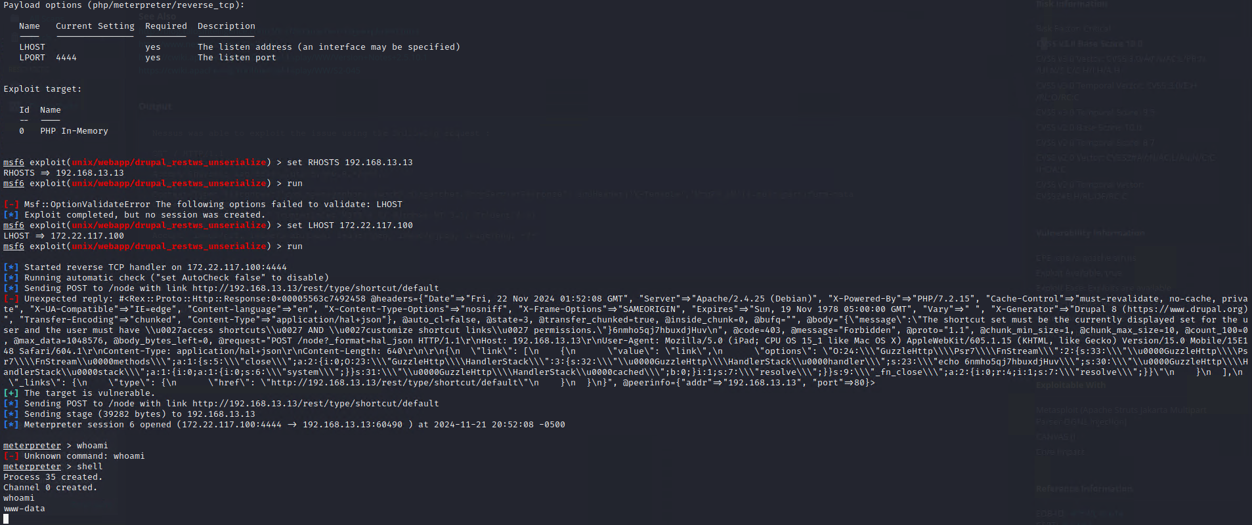

**Remediation**:

* **Update Drupal Core and Modules**: Ensure that both Drupal core and the restws module are updated to the latest versions to fix known vulnerabilities. Regularly patching software reduces the risk of exploitation.
* **Disable the restws Module if Not Needed**: If the restws module is not essential for your site, disable it to eliminate the vulnerability entirely.
* **Validate and Sanitize User Input**: Properly validate and sanitize all user inputs to prevent unserialization attacks. This helps to protect against RCE vulnerabilities that can be exploited through Drupal’s REST API.

### RCE Exploit | .12 IP

**Risk Rating**: **Critical**

**Description**:

I used an RCE (Remote Code Execution) exploit on a server using the multi/http/struts2_content_type_ognl module. This attack targeted a vulnerability in the Struts2 framework, specifically through the Content-Type header. By sending a specially crafted request, I was able to run arbitrary commands on the server. This shows the need to properly check headers and input to prevent similar security risks.

**Affected Hosts**: vpn.megacorpone.com, HOST

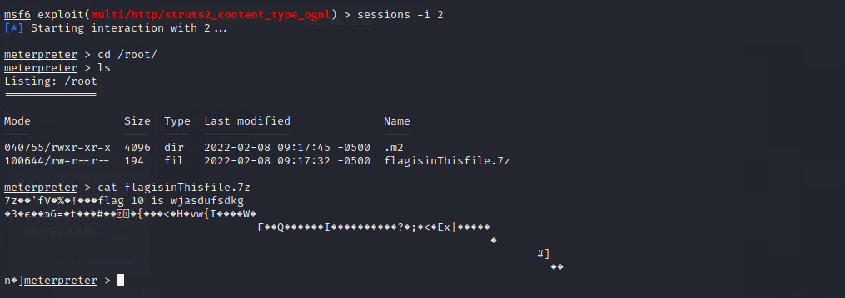

**Remediation**:

* **Update Struts2 Framework**: Ensure that the Struts2 framework is updated to the latest version that includes security patches to fix the OGNL injection vulnerability.
* **Restrict Header Modifications**: Limit the modification of HTTP headers to trusted sources and validate them properly to prevent attackers from exploiting header-based vulnerabilities.
* **Implement Input Validation and Sanitization**: All inputs, including headers and parameters, should be thoroughly validated and sanitized to prevent execution of unauthorized commands on the server.

## MITRE ATT&CK Navigator Map

The following completed MITRE ATT&CK navigator map shows all of the techniques and tactics that BSS used throughout the assessment.

Legend:

Performed successfully

Failure to perform

